/ (Forward slash) – It means present working directory **ROOT DIRECTORY**

~ (Tild) – It represents **home directory**

pwd - **present working directory**

cd - **change directory**

cd .. - **one step back**

cd ../.. -**two steps back**

ls - list

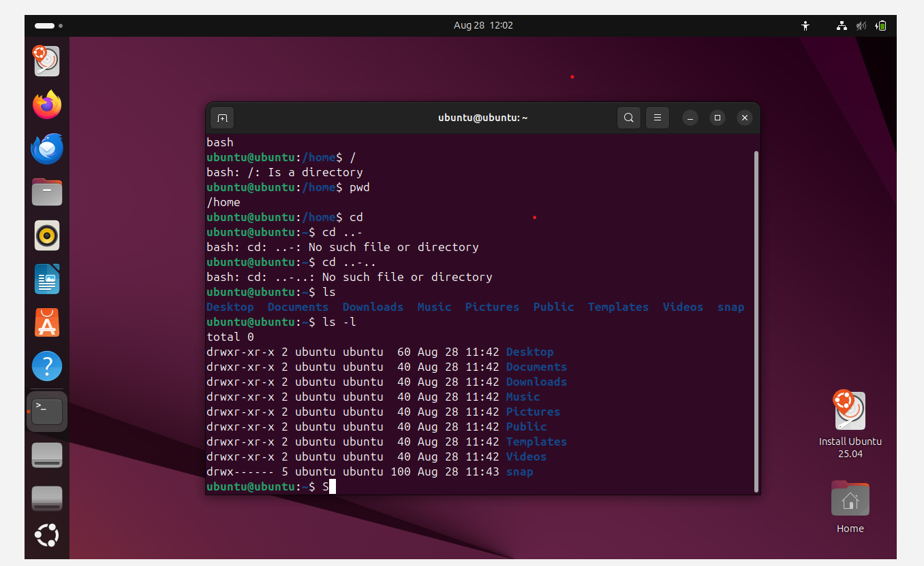

Ls – l – Lists with details

Ls -a – List of files and hidden files

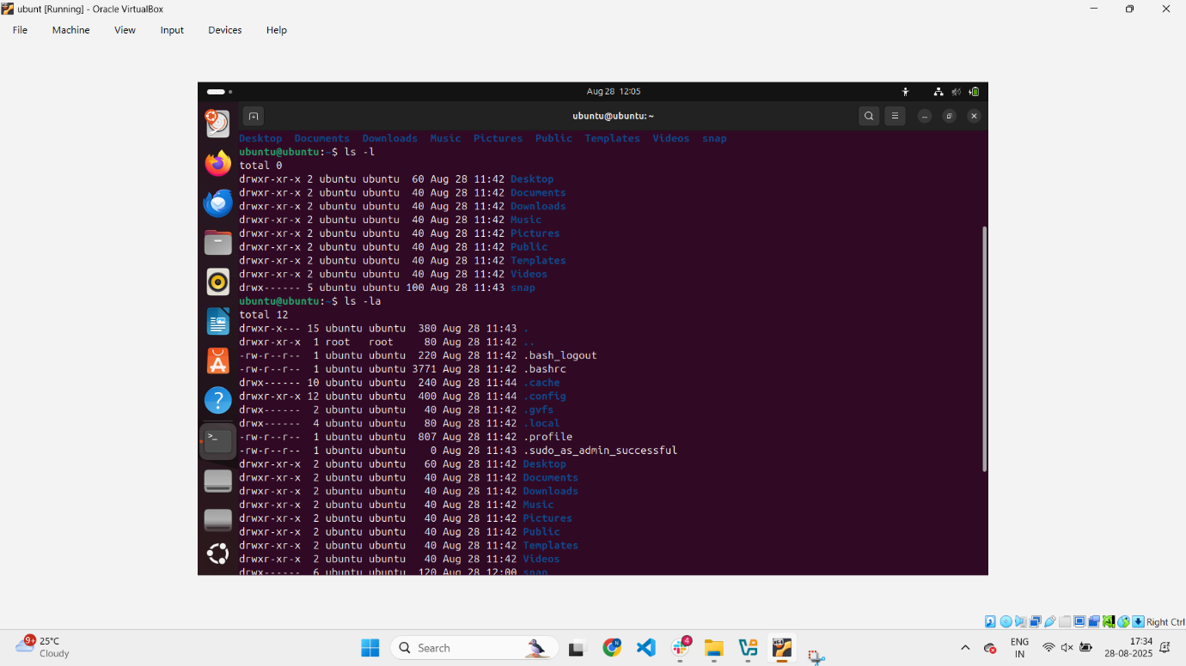

Ls – ls - list of files in sorting format(Higher volumes to lower)

ls -d */ -list all the directories only -

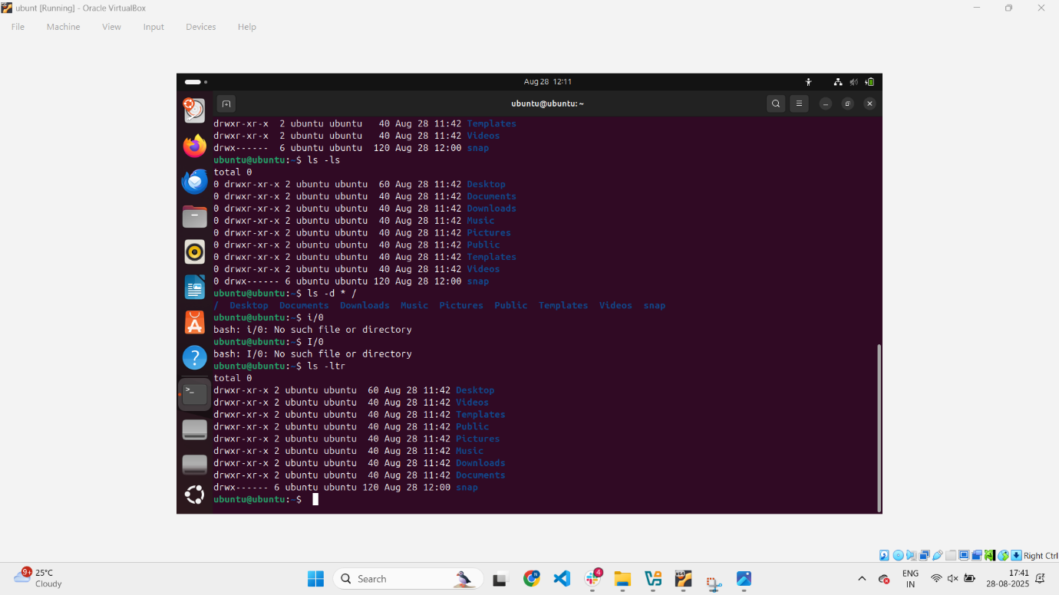

LS -LA – hidden files and and long list





History- to see the history

Mv -to rename a directory

Clear -clear the terminal screen

